24ADC001 — BUSINESS INTELLIGENCE FOR DECISION MAKING
CASE FILE: THE VANISHING QUARTER
OLAP Investigation Report
Submitted by: MOHAMED ASLAM A
Roll No:24BAD073
Department: Artificial Intelligence and Data Science
Tool Used:Microsoft Power BI
Dataset:meridian_retail_cube.csv
Date:04 September 2026

DATASET DESCRIPTION
The dataset contains the following fields:
Field | Description
Region | North, South, East, West
Quarter | Q1, Q2, Q3, Q4
Category | Electronics, Furniture, Apparel, Grocery
Channel | Online, In-Store
Sales Amount | Gross sales before discount
Discount Amount | Total discount given
Margin Amount | Sales amount minus discount amount
Discount Rate % | Discount amount as a percentage of sales amount

1. QUARTER ANALYSIST
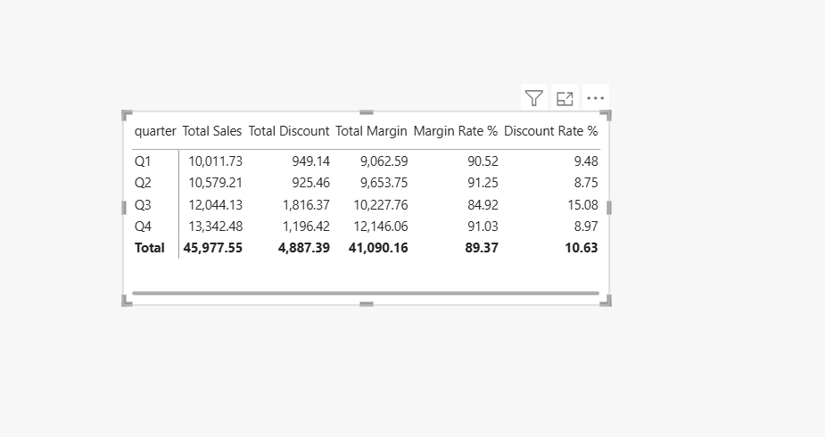
Observations
- Q3 is the main concern because it has the lowest Margin Rate (84.92%).
- Q3 has the highest Discount Rate (15.08%), much higher than the other quarters.
- Q3 generated ₹12,044.13 sales, making it the second-highest sales quarter.
- Q3 also has the highest discount amount of ₹1,816.37.
- Q4 has the highest sales (₹13,342.48) but a much healthier 91.03% margin rate.
- Observation: The Q3 margin problem is strongly associated with unusually high discounts.
2.REGIONAL ANALYSIS
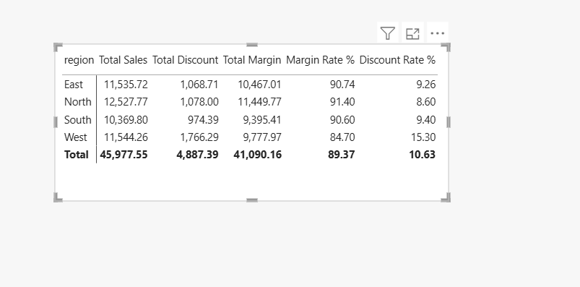
- Furniture is the weakest category with a Margin Rate of 85.58%.
- Furniture also has the highest Discount Rate (14.42%) among all categories.
- Furniture generated ₹13,247.55 sales, making it the second-highest sales category.
- Furniture has the highest discount amount of ₹1,910.08.
- Electronics has the highest sales (₹16,880.30) but maintains a much better 90.61% margin rate.
- Grocery has the best margin rate at 91.43% and the lowest discount rate at 8.57%.
- Observation: Furniture is a strong suspect because its high discounting is reducing its margin.

2.CATEGORY ANALYSIS
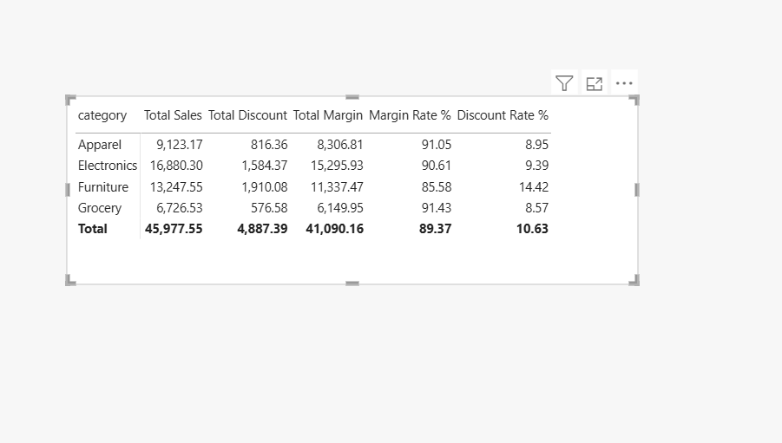
observation
- West is the weakest region with a Margin Rate of 84.70%.
- West has the highest Discount Rate (15.30%).
- West also has the highest discount amount of ₹1,766.29.
- West generated ₹11,544.26 sales, showing that the problem is not simply caused by low sales.
- North has the best margin rate at 91.40% and the lowest discount rate at 8.60%.
- Observation: West is the strongest regional suspect because its discount rate is significantly above the overall 10.63%.
3.CHANNEL ANALYSIS
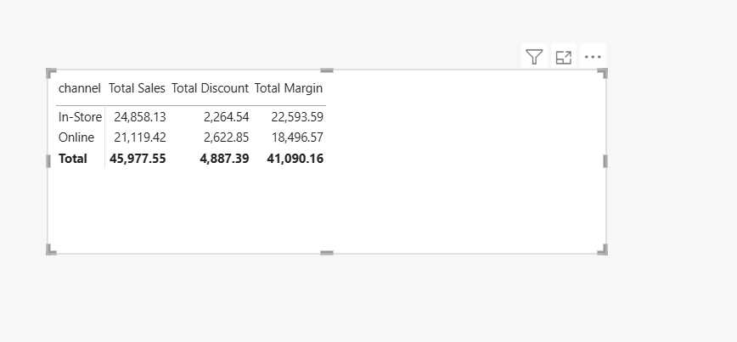
Observations
- The displayed channel result shows Online with:
  - Sales = ₹1,116.49
  - Discount = ₹821.34
  - Margin = ₹295.15
  - Discount Rate = 73.56%
- The 73.56% discount rate is extremely high compared with the overall discount rate of 10.63%.
- This indicates that the Online channel in the selected OLAP view has a very serious discounting problem.
- The resulting margin is only ₹295.15 despite ₹1,116.49 in sales.
- Observation: Online is a very strong suspect and should be investigated at the next drill-down level.

4.FINAL DRILL-DOWN
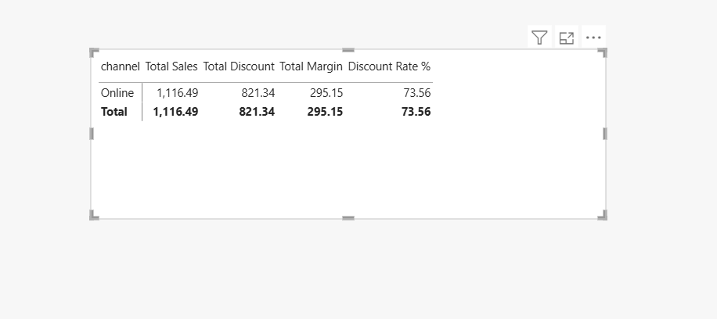
Final OLAP Observation – Channel
- Online channel shows a very high Discount Rate of 73.56%.
- Total Sales are ₹1,116.49, while Total Discount is ₹821.34.
- This leaves only ₹295.15 Total Margin.
- The discount consumes a very large portion of the sales value, resulting in a very low effective margin.
- Compared with the overall discount rate of 10.63%, the Online channel's 73.56% is exceptionally high.
- Conclusion: The Online channel is the strongest indicator of the margin collapse and should be investigated as the final drill-down level.
Final Case Finding
Q3 → Furniture → West → Online
Evidence: The Online channel shows a 73.56% discount rate and only ₹295.15 margin on ₹1,116.49 sales.
Recommendation: Finance should immediately review the Online–West–Furniture–Q3 transactions and tighten discount limits to protect margins.

